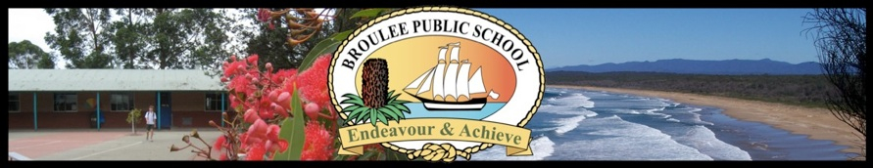
Principal: Matthew Rose
Broulee Public School
Cambridge Crescent, Broulee, NSW, 2537.
Ph: 44 716 120 Fax: 44 716145
Email: broulee-p.school@det.nsw.edu.au
Website: www.brouleepublicschool.nsw.edu.au

Year 4 Wollongong Excursion October 31 – November 2, 2018

29 May 2018
Dear Parents and Carers of Year 4 students,
Our excursion to Wollongong this year will run for 3 days and 2 nights from Wednesday, October 31 to Friday November 2, inclusive.

Activities will include a visit to the Nowra Fleet Museum, Nan Tien Temple, Flagstaff Hill, University of Wollongong Science Centre and Planetarium, Minnamurra rainforest Walk, Bowling, Flipout and Jamberoo Action Park.

Accommodation will be at Wollongong Surf Leisure Resort and travel will be by coach.
Broulee PS Staff and parent helpers will supervise students. The coach will remain with us throughout the excursion. The resort caters fully for school groups and will supply breakfast and dinner for two days as well as a packed lunch on the Wednesday. Morning and afternoon tea will be provided for the students and lunch at Jamberoo on the Friday is included in the cost.

During this time the students will be participating in many enriching educational and leisure experiences, allowing them opportunities to develop confidence and independence while experiencing different cultures and venues.

Our itinerary may change slightly as the excursion time draws closer. A full itinerary, will be provided shortly before the excursion.

The cost of the excursion is expected to be around $320.00. All food, (breakfast, lunch, dinner, morning and afternoon tea), accommodation, transport and venue entries are included in the price.
POINTS TO NOTE:
- We have budgeted for 47 students. To ensure your child’s place on this excursion a non-refundable deposit of $50 is required to be paid by Friday, June 29.

- A very limited amount of student assistance money is available to support families with educational expenses. It is not available to pay the deposit. Student Assistance may be available to help with part of the subsequent payments. Should you wish to apply for assistance please contact Mr Rose for a confidential discussion before you lodge the deposit.

- The balance of $270 is due by Friday August 31 2018. This balance may be paid in instalments or in one payment. Instalment payments must be completed prior to the excursion. Cash/Cheque payments are to be submitted to the front office. All cheques are to be made payable to Broulee Public School. Receipts will be issued for all payments. Online payments can be made using the DET’s Parent Online Payment (POP) system. A button to access this online payment system titled ‘$ Make a Payment’ will be visible on the utility bar on the front page of the school website at www.brouleepublicschool.nsw.edu.au. By selecting this link parents and carers can be taken to a secure Westpac QuickWeb payment page, from which they can make online payments.

- A comprehensive permission/medical note and a list of what items to bring on the excursion will be sent home to families during Term 3.

NOTE: Students who consistently demonstrate unacceptable behaviour at school during the year will be subject to a risk management review. This may result in their invitation to attend the excursion being withdrawn, as self-control and cooperation are vital skills needed to ensure safety at all times.

WHAT TO DO:

If you wish your child to attend this excursion, complete the payment envelope and include the deposit of $50 (or full payment if you prefer) and return to the Front Office any time before Friday June 29.

If you have any questions about the excursion feel free to contact one of the Year 4 Teachers.

Regards,
Janelle Morgan, Gee Hounsell, and Nerida Bourke (Year 4 teachers)

